SPRINT 2

|  |  |
| --- | --- |
| Date | 4 November 2022 |
| Team ID | PNT2022TMID24400 |
| Project Name | Personal assistant for senior people who are self-Reliant |
| Maximum Marks | 8 Marks |

Node Red Flow

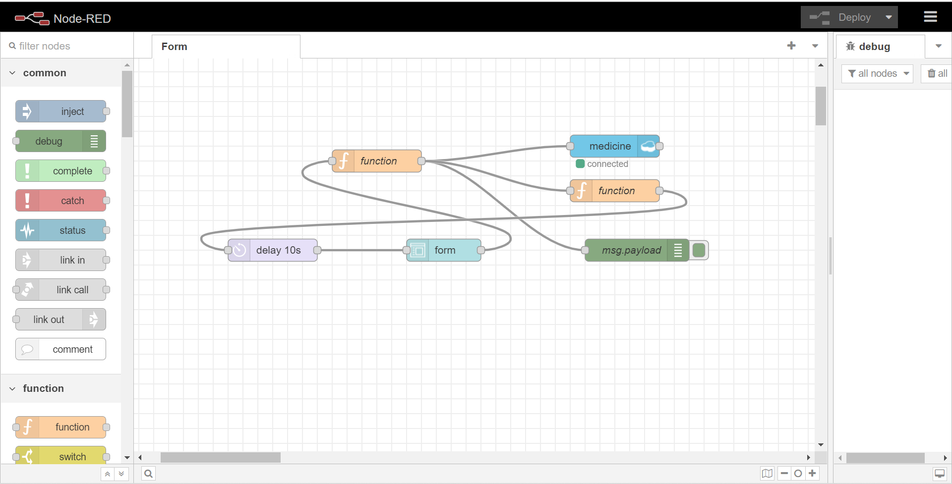

Create Form

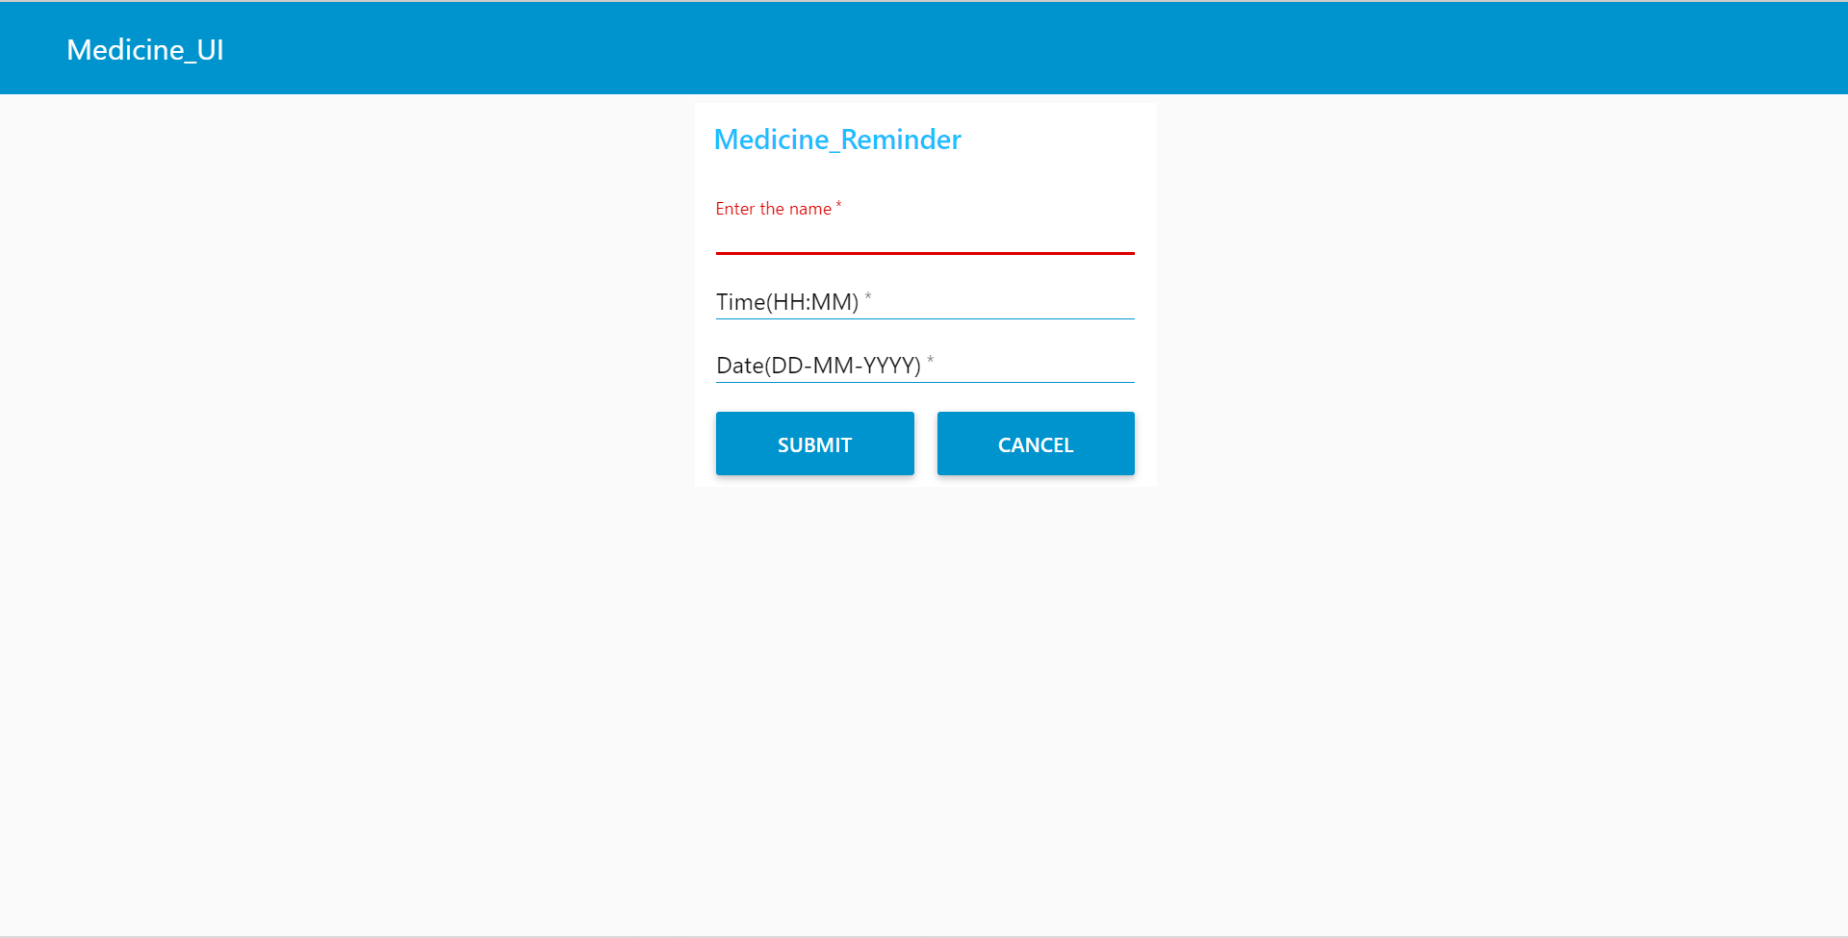

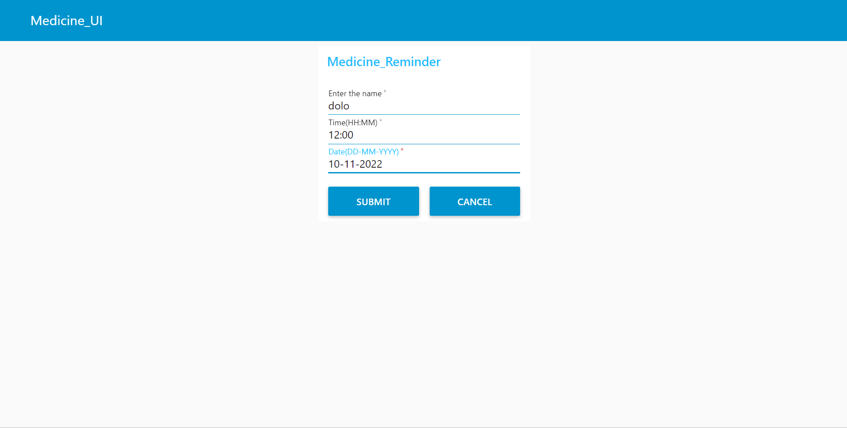

Storing Data into the Cloudant Database

